GTB  
  
**QA**  
[LIVE 20.18] OT-861 | XT | UK | AS | 3.0 Popin - Mach-E BP-C – 19 May 2020

**Jira ticket:**  
<https://jira.uhub.biz/browse/GTBEMEAOPT-874>

**Site**  
<https://www.ford.co.uk/>

**Test location**  
Across ford.co.uk - apart from E-comm configurator, E-comm Pre-order Journey, 1.0 Configurator and TDR

**Hypothesis**  
Analysis on the TDR Popin and UC5 has shown that TDR Popin converts at a higher rate than UC5 for TDR Completes. As such, we want to turn off UC5 and add the only vehicle included in UC5 in TDR Popin. Consolidating the two will also allow us to perform future AB testing to ensure TDR Popin is the best version it can be.

**Test Description**

View the ALL QA link. Mouse over the Vehicles link in the main heading. Scroll down and select the Mustang Mach-E. From here click on the “Pre-Order” or “Pre-Order Now” buttons. You have now started the Build and Price journey. Go through all the steps until you reach the summary page, as shown below.

The popup will now be able to appear if you leave this page now.   
~~“~~[~~https://www.ford.co.uk~~](https://www.ford.co.uk)~~” to go to the home page, the popup will appear in roughly 15 seconds.~~

The popup can only appear on the below pages:

* <https://www.ford.co.uk/cars/mustang-mach-e>
* <https://www.ford.co.uk/shop/price-and-locate/promotions/personal>
* <https://www.ford.co.uk/shop/research/technology>
* <https://www.ford.co.uk/shop/research/hybrid-electric>

Summary Page:  
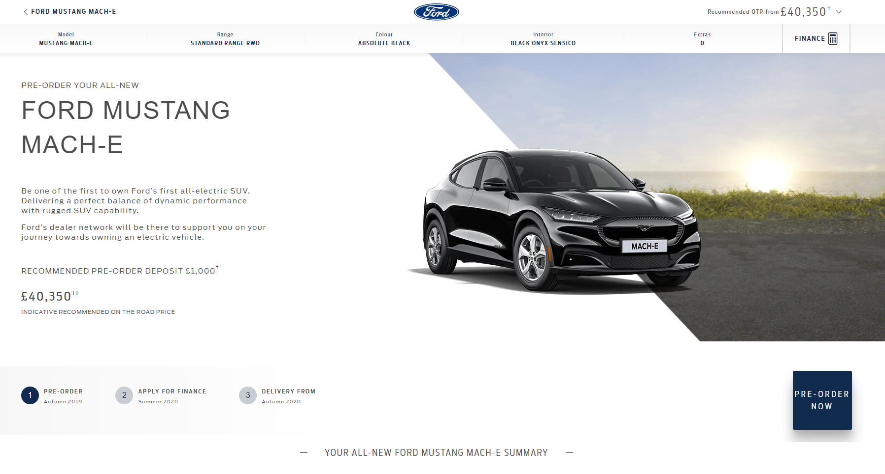

The Popup should look something the below

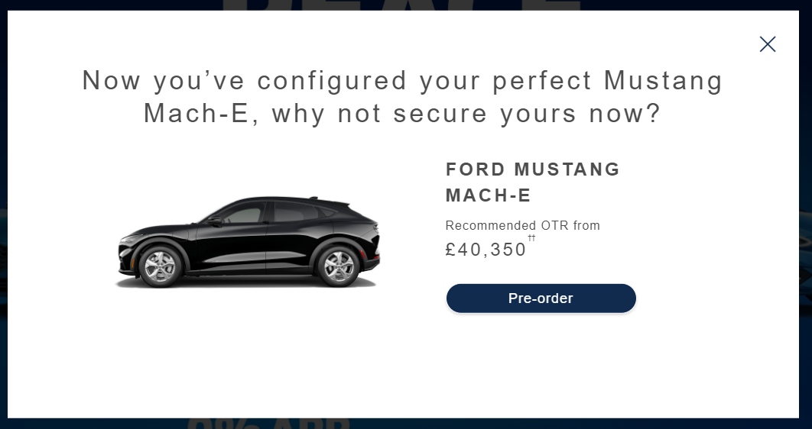

The mini popup should look like the below:  
  
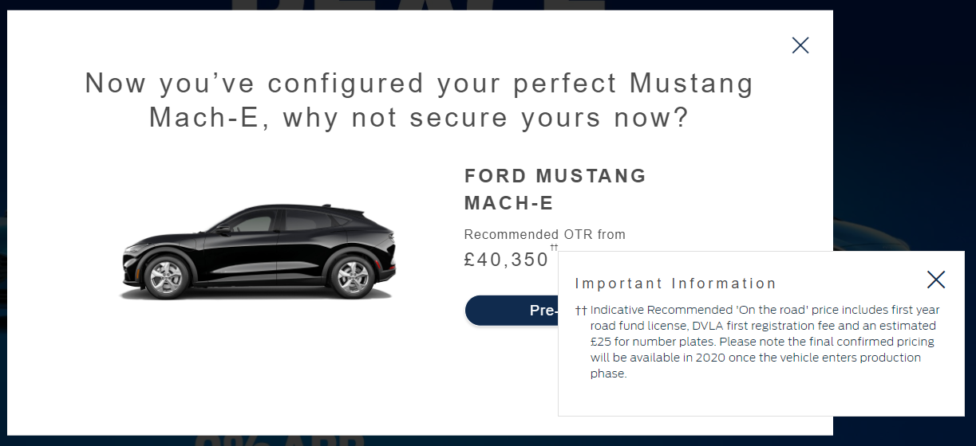

The CTA button should take you back to the summary page.

Now view the ORDER COMPLETE QA link, and then view the ALL QA link again. The popup should no longer be visible. Unless you were to go through the above steps again to get to the summary page.  
  
**Browser:**   
All  
  
**Device:**   
All  
  
**Audience rules:**   
All traffic

**QA Links:**

**ALL:**

[**https://www.ford.co.uk/cars/mustang-mach-e?at_preview_token=SAsj9V1zsWUqsCaY0m1fCw&at_preview_index=1_2&at_preview_listed_activities_only=true**](https://www.ford.co.uk/cars/mustang-mach-e?at_preview_token=SAsj9V1zsWUqsCaY0m1fCw&at_preview_index=1_2&at_preview_listed_activities_only=true)

**ORDER COMPLETE:**

[**https://www.ford.co.uk/cars/mustang-mach-e?at_preview_token=SAsj9V1zsWUqsCaY0m1fCw&at_preview_index=1_1&at_preview_listed_activities_only=true**](https://www.ford.co.uk/cars/mustang-mach-e?at_preview_token=SAsj9V1zsWUqsCaY0m1fCw&at_preview_index=1_1&at_preview_listed_activities_only=true)